Jessica’s PEP

(Maybe an interesting image?)

Table of Contents

Week 1 3

Key takeaways 3

Technical Skills 4

Professional Skills 6

Week 2 7

Key Takeaways 7

Technical Skills 8

9

Professional Skills 11

Week 3 12

Key Takeaways 12

Technical Skills 13

Professional Skills 15

Week 4 16

Key Takeaways 16

Technical Skills 17

Professional Skills 20

# Week 1

## Key takeaways

In this first week I got to dip my toe in the subjects, and I struggled with Media design, using Figma and prototyping so I ran late in my opinion to deliver my PEP. On the social standpoint I had a hard time navigating between my peers but now the professional skill I have taken the most interest in is Speaking skills.

## Technical Skills

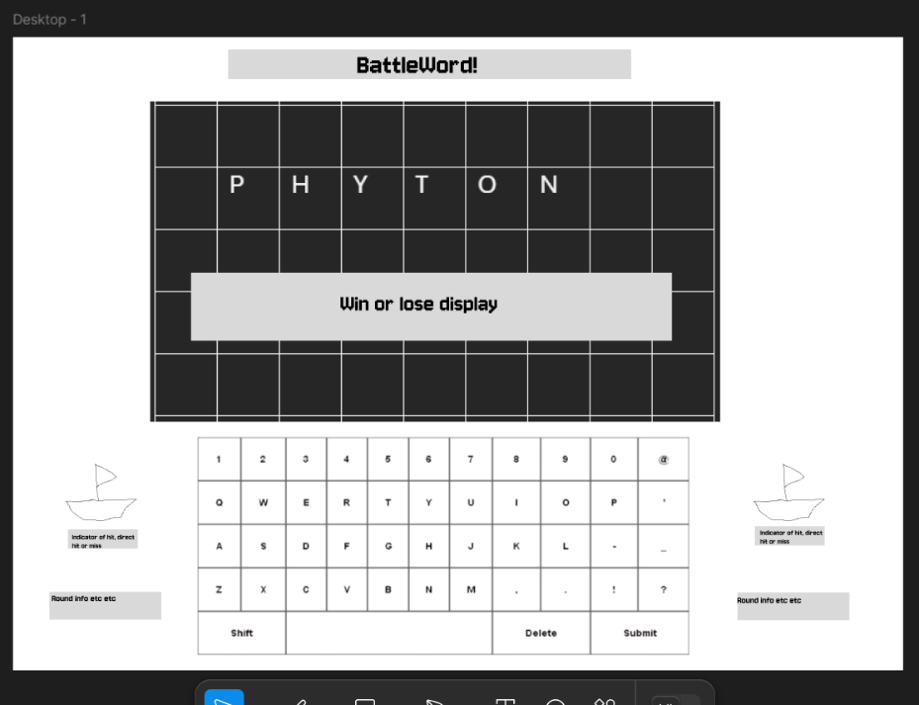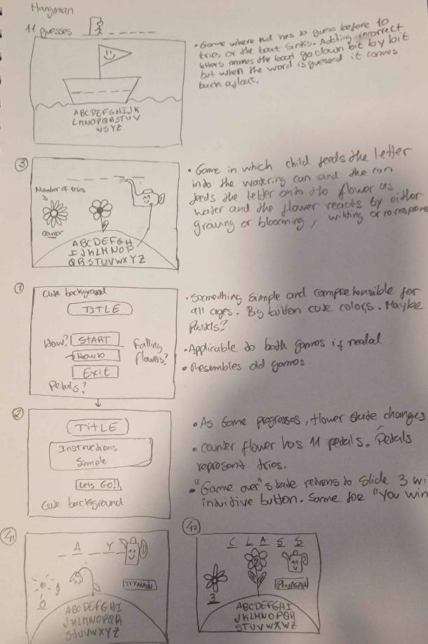Starting off with my Achilles heel, we got media design. For the media design I created a prototype for a game that started with a slight misunderstanding of the assignment that was quickly resolved. I have since then created the new prototype and decided to go off that for the Figma prototyping project. It was fun but frustrating, had to watch some videos on Figma and ask for some assistance. Here is a rough sketch of both prototypes:

1. Picture of the first prototype idea

2. Picture of approved prototype

<https://www.figma.com/design/dziWMdReIPFjGIbU6W1PLV/Actual-Prototype?node-id=0-1&t=IWTmAyqDMbBMHyb2-1> is the “final product” of my prototyping venture.

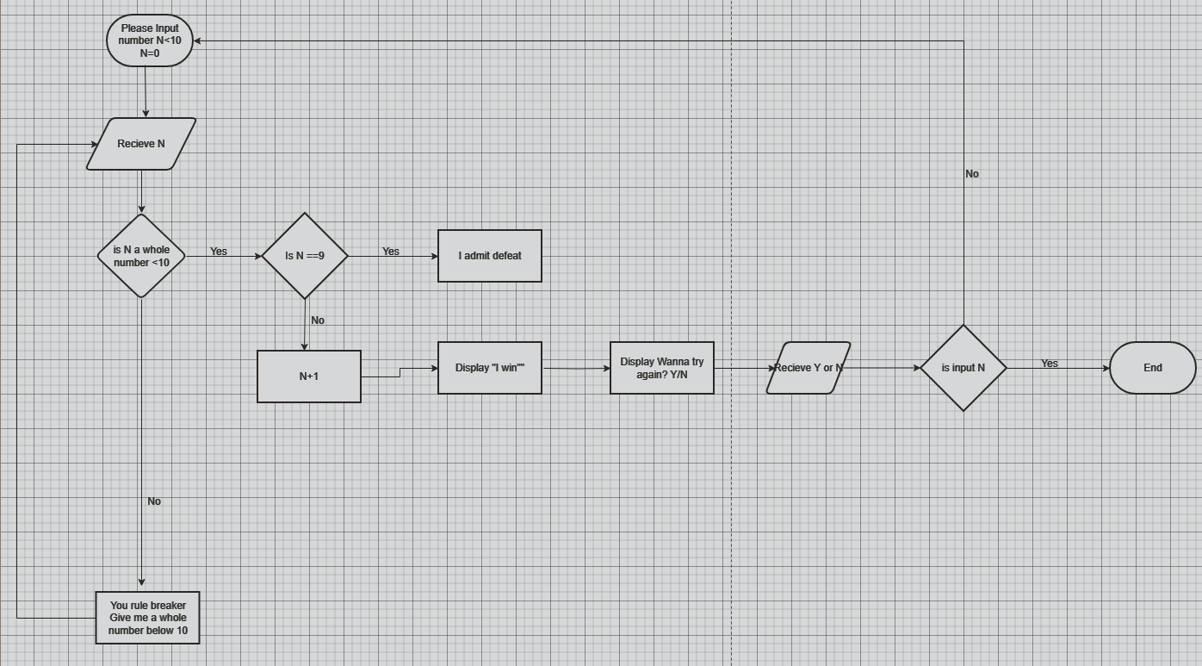For Software engineering, I have made flowcharts and dabbled in some python exercises. I was not very good with flowcharts. I have done some research and watched some video tutorials in python and flowcharts and have achieved my goal. I shall zip a file with all my code from last week and here are some flowcharts I made! In the zip I include my initial flowcharts and the most recent ones. Progress!

These are the flowcharts of week 1 in the working document. In the attached zip there will be the rest of the flowcharts that I made and the code I made from the flowcharts.

## Professional Skills

As mentioned before, for professional skills I aim to become better at speaking to improve communication with my classmates. I was diagnosed with social anxiety the past year, so I tend to be quiet when someone is confrontational or disapproving. I have worked on many parts of this, but I feel that it is important for me to be clear in both professional and non-professional settings. I got interested in the skill build website from the power point presentation and will work in making a more concrete goal than “I want to be clear” therefore for now the diagram looks quite poor. It is also a personal want to work on minimally a second skill by the end of the school year, hopefully that is not too ambitious!  
I have also done the character strength quiz, and my strength was Honesty.  
Note that as it is week one I am not certain that this is what is expected of me so with some feedback this might change.

# Week 2

## Key Takeaways

For this week my key takeaways were that I need more structure to how I manage time. As a working student it is not so easy, but it is possible. The speaking skill got a small peek, but the Research topic took most time in my head! I feel like it is important to get started as soon as possible. The HTML was very interesting, and I enjoyed making something appear on the screen to interact with! I am excited for the development of the small website.

## Technical Skills

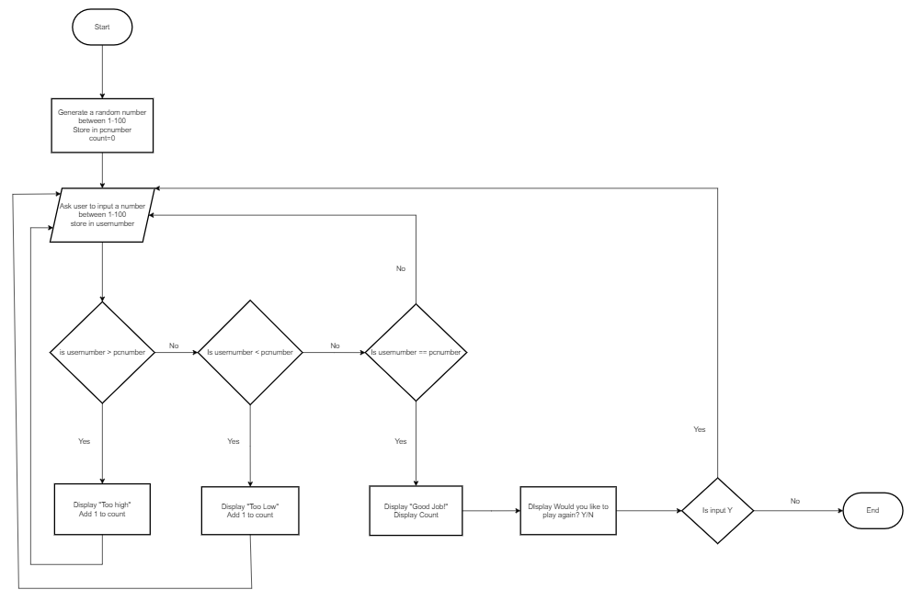For this week we started with HTML and made a website. I used some help from YouTube and w3 schools and managed to make a somewhat funny website: <https://i548425.hera.fontysict.net/>.  
For Software this week we learned about strings and random numbers and during class and the open space we applied some of that material. I made some flowcharts for the assignment (Attached Zip file), below is an example:

With this one I had to do a lot of testing and change many things to get this one right. Also had to add the squares for the bonuses. It was interesting to try to get the while loop working and to get every step coded. After some mistakes I made it happen!

Additionally, I coded the flowcharts in VS code (zip file). Here is an example of the guess the word game from the challenge.

It seems that the only way out of the loop is to guess the number. I believe I should add a like after the except print to stop the code from running else it will just ask for a number forever!

I had a hard time with this flowchart because I do not really know how to simplify it more or make it into a loop to be honest? I have many doubts about it! But as a learn I hope to get to a point where I can correct this myself. I am unsure if this logic works at all. And because of social doubts I did not ask anyone for help or feedback.

As for the research topic I have ideas for it and since I would like for it to be related to me and my curiosity so I would like to research about Linux and the question is: Why isn’t Linux as popular as Windows or IOS operating system since it is so useful and revered? Something among those lines. I had a hard time with the Inform the Boss flowchart and did not manage to do it properly (I think).

## Professional Skills

I started the skill builder, and I started with the simplest exercise for speaking, “Mirror Image”, an exercise where I stand in front of the mirror and introduce myself. It was a bit awkward, and I stopped talking due to secondhand embarrassment once or twice, but I feel I must instead practice with the Shared reading activity, to have feedback from others. During this week I will gather some feedback from this activity. I will also make the recording exercise and add it to my PEP.

# Week 3

## Key Takeaways

As the world of coding unfolds around me a realize more and more, I need to quit my job as soon as possible and reduce my hours of work to make them into hours of studying. I feel an urgency to do everything in my power to overcome my difficulties and solve the issues or rush into the projects that were presented this past week. I came across my first stump and instead of working on it I spent my weekend putting clothes away. I feel like I didn’t put enough effort or time into it. And I am quite disappointed I couldn’t finish the rainfall assignment. Therefore, for the next week I am investing more my time into the assignments and my professional skills.

Overall speaking I am quite disappointed with my progress this week and I would like to progress more and ask for more feedback.

## Technical Skills

For this week we had the research topic, challenges in Python, Arduino and CSS.  
As for the research topic I’ve decided it is interesting to make it about Linux and its popularity or lack thereof. I feel this is the question that will give me the most knowledge (and perhaps convert myself into a Linux user?). I aim to have some information about it already by the end of this week.  
For the challenges of this week we have the rainfall code where I faced difficulty. I had no idea how to properly connect the functions to have it calculate averages of the weeks of data. I managed to get the code to separate my data for the weeks but after that it somehow drew into a blank. With some feedback from the teacher and some help this is where I stopped. I admit I am quite dissatisfied with it, and I would have liked to finish it.

For this week I also progressed with the HTML and made a style sheet. It looks like some things are not centering well on other screens perhaps because they are relative positions, and the button style was not working so I did not manage to make it on theme with the rest. I also haven’t figured out how the div works that well! I also aim to connect the “let’s go” button and make a better intro page with the flowers. The color pallet is simple because I have noticed the green with other colors is so jarring and hurts the eyes! It was interesting to make the style. <https://i548425.hera.fontysict.net/> is where the greenery is at. I must improve/study color theory… And I should start illustrating it too.

For the Arduino we had a simple blinky blink program. I worked on this mostly at school since my time was mostly taken trying to fix the python program and working. It was entertaining to see the results of written things! It seems like there is much more to technology than I knew about. Overall, for this assignment I am a bit disappointed too because I did not finish the alternating blinking.

## Professional Skills

For this week I focused in getting feedback about a random speech I made about a game. I asked some of my friends on some feedback about my communication and I had some interesting results about how I abort my train of thought or sentences mid speech, a lot of “ah uh” and the awkwardness when talking while they are silent. Additionally, I asked whether I am a high or low context kind of person, after explaining it to them, out of curiosity. My feedback was mostly that I interpret what they say, and it leads to miscommunications. I felt it is important to my speaking skill to adapt more and be mostly low context, so along with my development in speaking I will attempt to be direct when speaking.

# Week 4

## Key Takeaways

I put in a lot more effort into keeping up with the study material. It got a bit messed up but with a bit of feedback I managed to get back on track! I got some feedback on my Arduino assignment and applied it. Reflectively it went a lot better than week 3 and I have gotten a new job and will reduce my hours to maximize study time. I have not put much effort into my professional skill this week because I want to apply more onto technical and my research.

## Technical Skills

Arduino as very fun with a couple of assignments that will lead into the greenhouse project. I enjoyed struggling with it although getting to know the language by making the compiler angry isn’t my preferred approach, I managed to finish all the challenges for the Arduino. I will attach in the zip file the correct code, here are some bloopers about it.

And this one is the very beginning, trying to use python logic because I assumed it would all be the same. It is quite entertaining looking at it!

This one got me for around 30 minutes and made me realize I need to change the state to the previous.

Additionally, there were computer networks challenges:

Here is the Challenge 2 diagram. I will try to include a bigger version in the Zip file. But long story short my solution was to make a Vlan network that would separate the traffic and simplify it. Also increases speed and security!  
I haven’t asked for feedback yet but I am hoping this is actually a viable solution for the case.

Some information is an assumption (for the upstairs area) since I have never physically seen their router or wireless extender, but the studio is where I live.

For the business it seems I completely missed the assignment of business. I read the presentation and immediately went to work on the weekly challenges. In hindsight I should have probably asked myself more about the business but in class we did some exercises and for that day and I went to work and missed the extra class about data. I have yet still to catch up. I will work on it soon or allocate time for it.

## Professional Skills

For this week I haven’t done anything about this skill as I focused more on the technical ones. I did continue the skill builder and watched the video about speaking to groups and the training exercises are there, but I haven’t applied them yet. As it is now I am mostly focused on technical skills as it feels it is urgent for me to learn everything and progress on the project and the research so professional skills were a bit lacking for this week.